



Data Structures & Algorithm
LAB MANUAL

Disclaimer: The content is curated from online/offline resources and used for educational purpose only
Implementation of Linear search

Objective:
To implement linear search for a target element in a list.

Equipment Required:
- Computer with Python installed, text editor/IDE.

Prerequisites:
- Understanding of binary trees
- Basic Python programming skills
- Familiarity with recursion
- Loops, list manipulation, basic sorting logic.
Problem Statement:
Search for a specific element in a list and return its index.

Procedure:
- Define a list of elements.
- Take input for the target element.
- Traverse the list.
- If found, print its index.

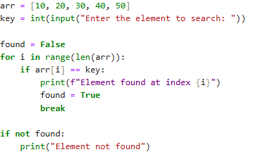

Output:

